

CABLE SPECIFICATION
Issued: August 12, 2010
Revised: ---
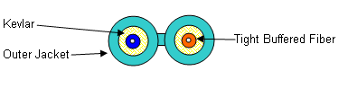
ITEM: 10-002-12D-AANONF

Fiber Diameter (core/clad) microns 50/125*
Fiber Type Multimode Graded Index
Numerical Aperture -- 0.20, ±0.015
Maximum Attenuation @ 850/1300nm dB/km ≤3.0/1.0
Bandwidth @ 850/1300 nm
(Overfilled lauch, LED based sources) Mhz.km ≥750/500
Transmission Link Lengths at 850nm
& 1300nm(LX4) for 10Gb/s* meters 150/150

Number of Fibers -- 2
Buffer Diameter microns 900
Storage Temperature Range °C -40 to +70
Operating Temperature Range °C -20 to +70
Max. Tensile Load for Installation N (lbf) 1000 (225)
Max. Tensile Load, Long-Term N (lbf) 500 (112)
Min. Bend Radius, Unloaded -- 10 X O.D.
Crush Resistance (EIA 455-41) N/cm 100
Impact Resistance (EIA 455-25) Impacts 25
Flexing, ±90° (EIA 455-104) Cycles 25
Cable Outside Diameter, Nom. mm (in.) 2.9 X 6.0(0.114 x 0.235)
Cable Weight, Nom. kg/km (lbs./1000) 18 (12)

DESCRIPTION: 2 tight-buffered fibers, aramid yarns, Aqua riser rated PVC outer jacket in a zip cord construction, OFNR C(ETL)US.
**Note: The values listed herein are nominal. Remee Products Corporation reserves the right to modify.

